Get Started – Cisco Jabber Softphone – Mac and iOS

Cisco Jabber Softphone allows you to use your office local when working remotely. It has most of the functionalities of your physical office phone plus some extras. This guide just focusses on the basic phone features.
After you’ve requested your Softphone account, you may need to ask for software to be installed. Cisco Jabber which includes the Softphone functionality can be installed on iPhones, iPads, Apple Watch and macOS computers.
Download Cisco Jabber For Mac
Install Cisco Jabber for iOS/Apple Watch (visit link on your device or search for Cisco Jabber in the App Store)
Make sure to login in VPN. Once your software is installed, sign in with your netlink@uvic.ca username and UVic password.
Note: Audio/video calls with Smartphone are not supported on remote.uvic.ca.
If you need to use your phone while using remote.uvic.ca you can install the Cisco Jabber software on an iOS or Android mobile device. However this requires specific configuration when you request access to the Softphone service.

General preferences
- Go to Jabber in the menu bar and choose Preferences…
- You may want to have Start Cisco Jabber when my computer starts
- Make sure to Start calls with: Cisco Jabber
- You can adjust notifications
- You can change how calls are handled and change how the app appears

Adjust Audio preferences
- In Cisco Jabber, Go to Jabber in the menu bar and choose Preferences > Audio/Video
- If you want to use a headset, plug it in first. Then make sure the right devices are selected under
- Make sure the right devices are selected under “Audio Call Output” and “Microphone”. You can test the speaker/headset/headphones by clicking on the button. Make a noise and see if the microphone input shows the sound levels. You can change the setting for When you connect a new microphone or speaker to your computer, Jabber will.
- If your microphone isn’t working but is selected, check its volume in Apple Menu > System Preferences > Sound > Input
- If you will be using the Video option and have more than one camera available, make sure the right camera is selected under Video. Make sure the camera preview is as expected.
- If your audio or video devices still aren’t responding, try restarting your Mac

Receiving a call
You must have Cisco Jabber launched and be signed in and connected to VPN to receive calls. This applies to Mac or iOS devices. Also keep in mind that any settings on your physical phone or in your softphone apply. So if you have setup forwarding to voicemail, this will also happen on the Softphone and you won’t receive calls.

You should get an alert when you receive an incoming call that looks like this:
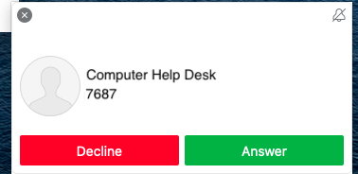
Making a call
You can make a call in one of two ways by finding the number you want to call:
- Search your local contacts or the UVic directory by typing in the name of the person in the search field (type as much as you can as Jabber only displays the first 15 matches). Then click on the contact and click on the green phone icon next to the name. If there is no green icon that contact doesn’t have a phone associated with their name: 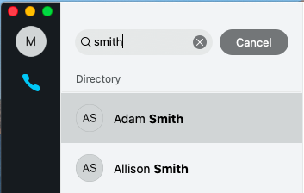
- Type in the full phone number in the search field. This can be either the 4-digit local:
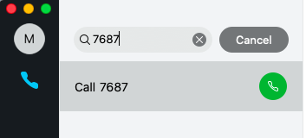
Or an external number (remember to dial as if you were on your physical phone – type 9 first and then the full phone number with area code):
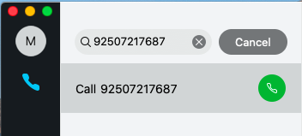
Click on the green phone icon next to the number you want to call.
While on a call you can also hold or transfer a call by clicking on the … ellipsis.
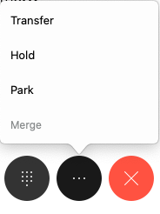
Hold will allow you to log into Jabber on another device and then click on Resume on that device to continue the call.
Hang up by clicking on the large red X.
Forwarding calls
To forward calls to either your voicemail or another number when calls come in, go to Jabber Preferences and to Calls. Click on Call Forward and then either choose voicemail from the drop-down menu or add a number using the + sign at the bottom and choose it in the drop-down list.
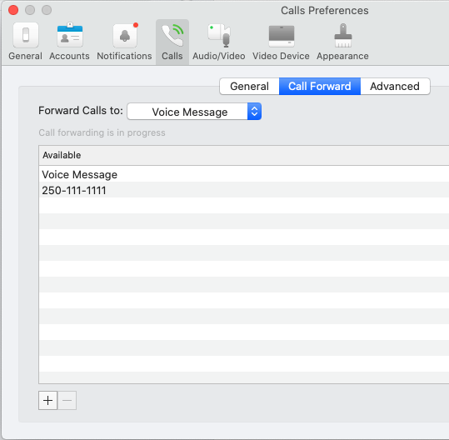
You will also get a reminder that your phone is being forwarded at the bottom of the main window:
To turn forwarding off, simply go back into the Preferences and choose Do Not Forward Calls

