

**GEOGRAPHY 370 A01**

**UNIVERSITY OF VICTORIA**

**Spring Term 2025**

**Dr. Matthew Asplin**

**COURSE OUTLINE**

**Methods in Hydrology**

**Office Hours**: Mondays10:00 to 11:20 am

**Office Location: DTB B204**

**Contact:** [asplin@uvic.ca](mailto:asplin@uvic.ca)

When emailing me please include ‘GEOG 370 - your name - brief subject’ in the subject line. This helps me sort through emails and makes it easier to track and respond to your message.

**Profile**: I an Adjunct Assistant Professor in the Geography Department with a diverse background in synoptic climatology, sea ice, meteorology, hydrology, and oceanography. I am passionate about hydrometeorological topics, hydroclimate change, renewable energy, and field-based learning. I am also a senior manager and metocean and hydrological scientist at ASL Environmental Sciences Inc., a local oceanographic & aquatics consulting company.

**We acknowledge and respect the lək̓ʷəŋən peoples on whose traditional territory the university stands and the Songhees, Esquimalt and W̱SÁNEĆ peoples whose historical relationships with the land continue to this day.**

**COURSE DESCRIPTION**

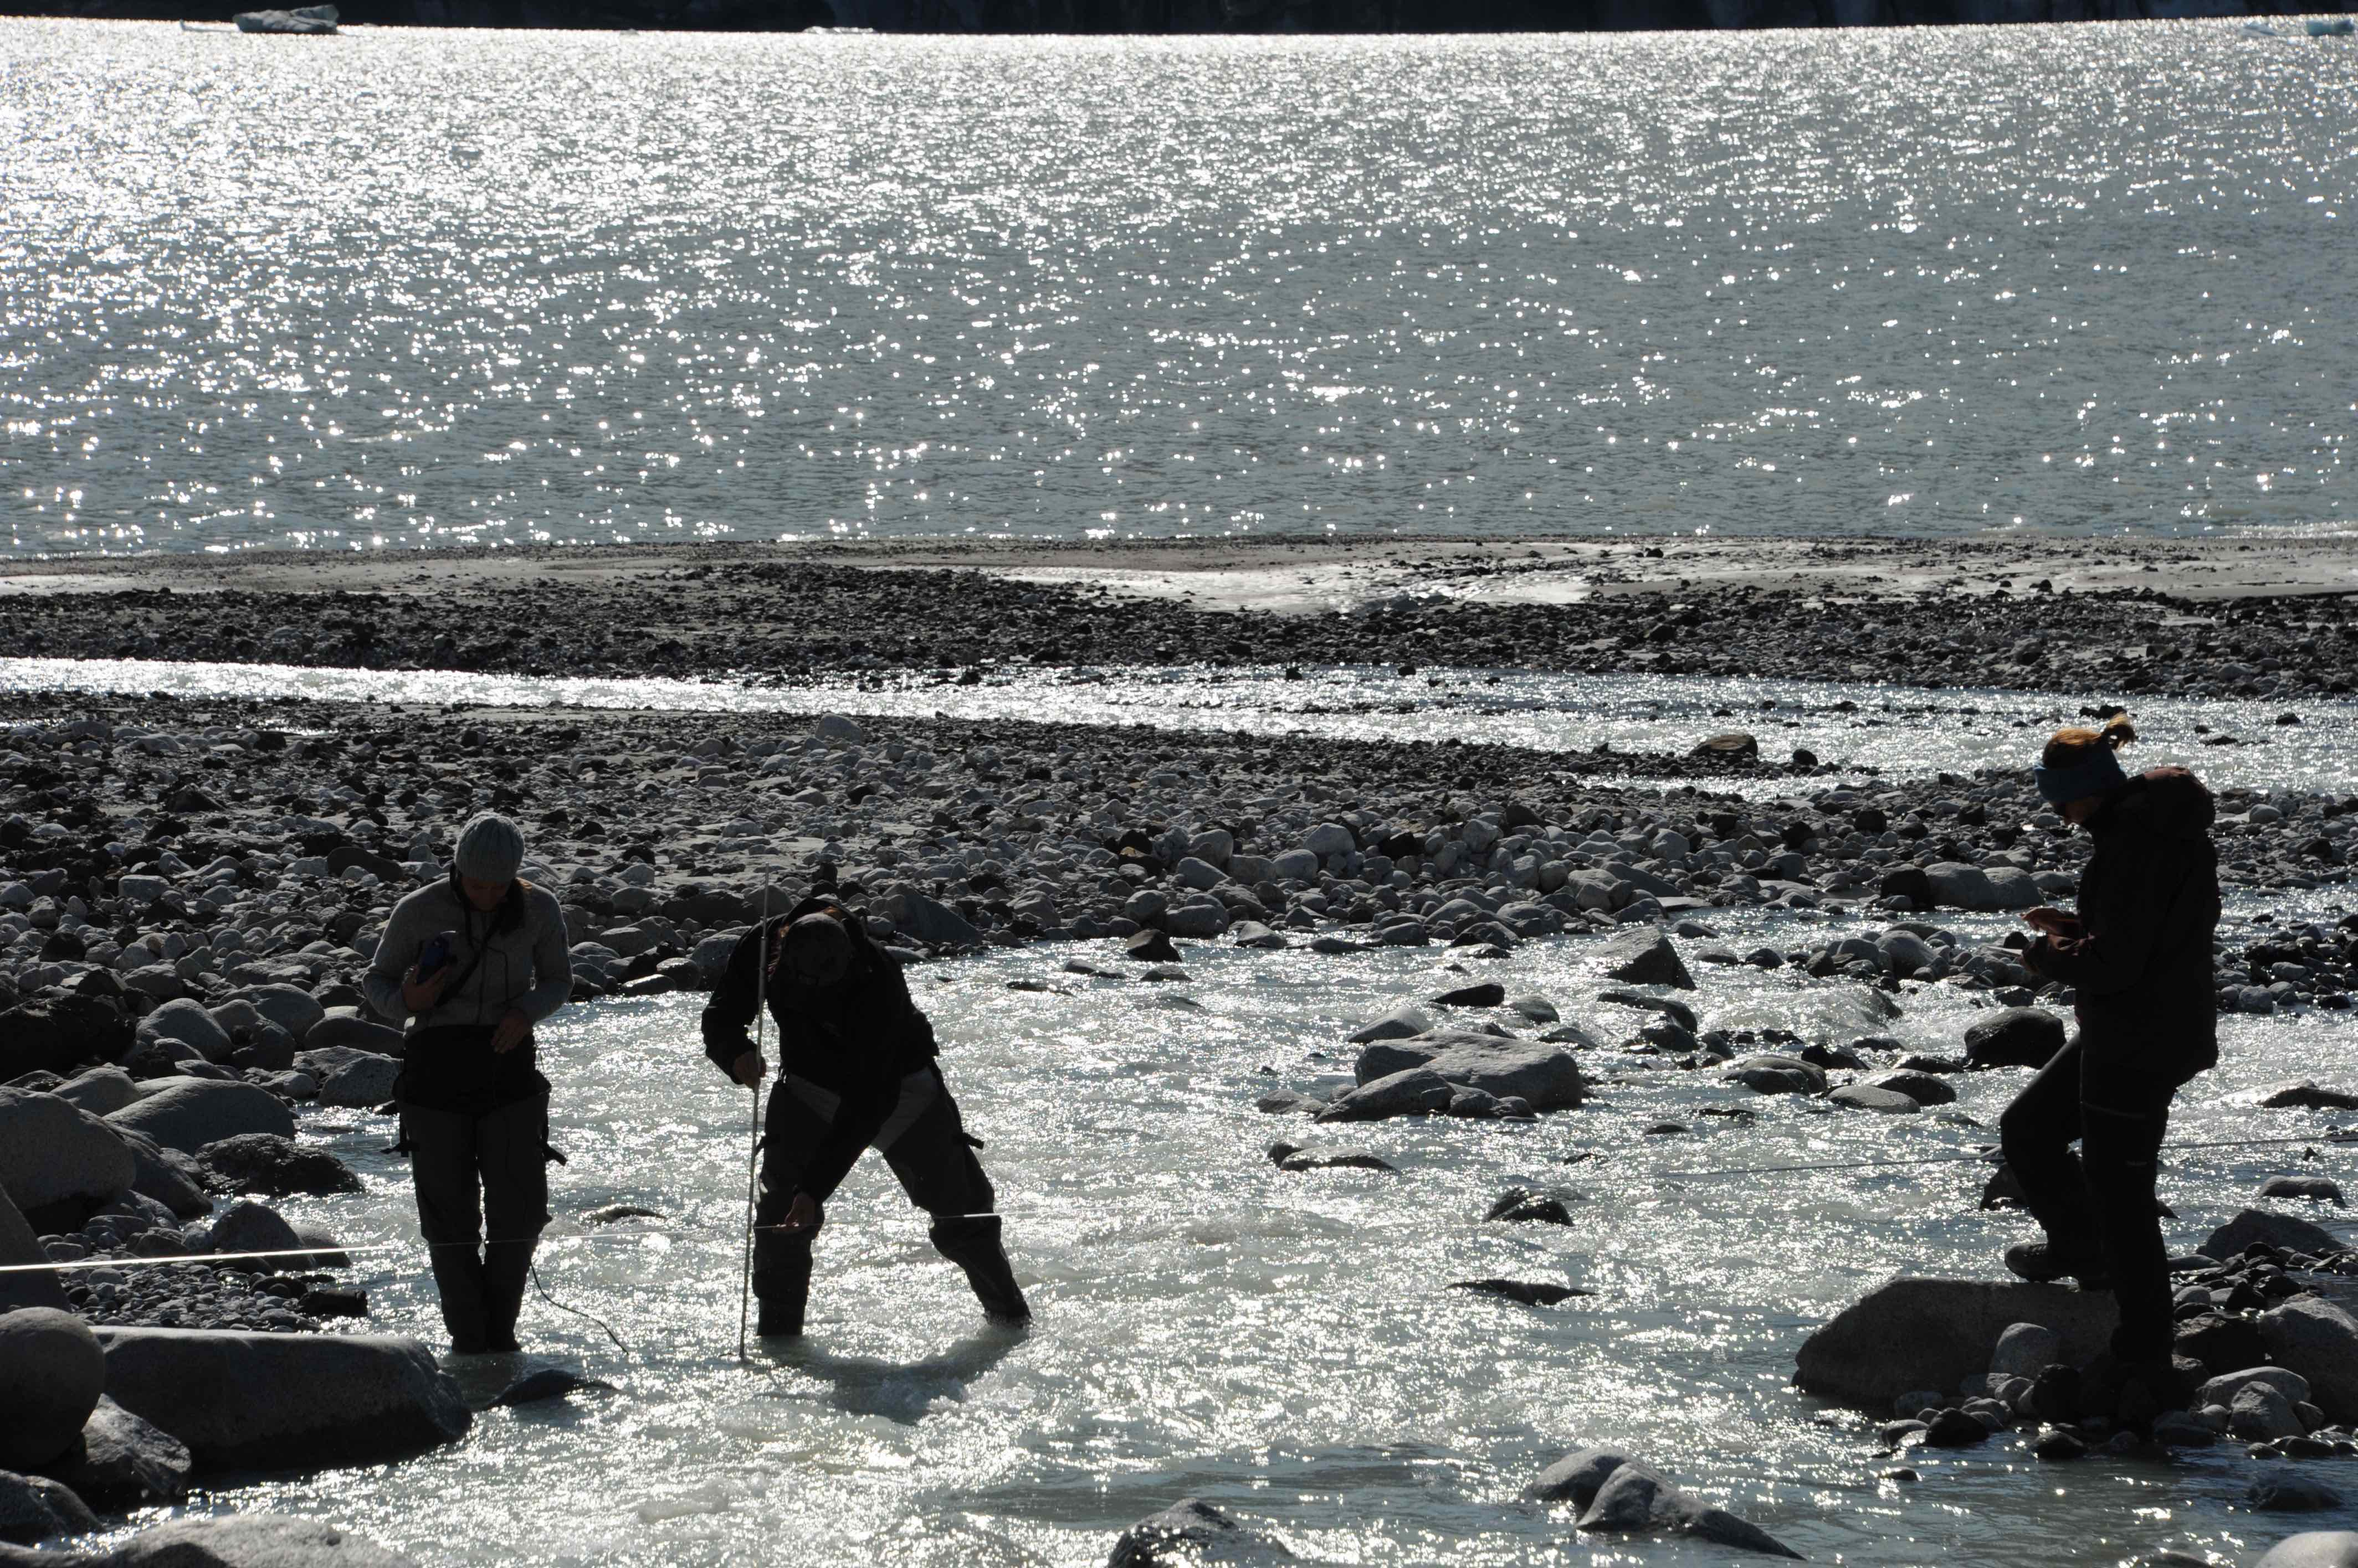This course provides an overview of hydrological processes, measurement techniques and data analysis. The movement of water in the hydrologic cycle via precipitation, interception, evapotranspiration, surface runoff, infiltration, soil moisture, groundwater flow and streamflow generation will be examined. Applied aspects and local examples will be discussed. Lecture material is complimented by laboratory assignments, and an optional field trip on a Friday in March.

**Class Meetings**: Mondays and Thursdays 11:30 am to 12:50 pm

Location: Clearihue Building A317

**Lab Information**: B01 M 2:30 pm to 4:20 pm A253

B02 T 2:30 pm to 4:20 pm A253

Instructor: Jaymie Fletcher: <jaymiefletcher@uvic.ca>

**KEY THEMES:**

Hydrological systems, watersheds, the water cycle, groundwater, climate change, cold regions hydrology, extremes

**REQUIRED TEXT**

Davie, T. (2008). Fundamentals of Hydrology (2nd Edition). Routledge.

Digital copy provided on BrightSpace.

**LEARNING OUTCOMES**

1. To understand the different hydrological processes involved in the hydrologic cycle.

2. To know how these hydrologic processes differ at a variety of scales (local, regional, global).

3. To learn about and practice basic measurement and data analysis techniques in hydrology.

4. To investigate how recent and anticipated changes in the hydrological cycle impact water quantity, quality and availability.

**EVALUATION**

Midterm Exam (February 10th in class) 15%

Final Exam (During Exam period) 30%

Lab Exam (April 3rd in class period) 15%

Laboratory Assignments x 5 36%

Sooke Watershed Assignment (due: Apr 4th) 4%

Exam Format: The questions for the midterm exam and final exam will be based on lectures, posted learning resources and class discussion. The midterm test will cover only the topics discussed immediately preceding it. The final exam is comprehensive, but will be weighted more heavily on material not previously tested on. Format includes a combination of short-answer, problem-solving and multiple-choice questions. The lab exam questions will be based on lab assignments, background material and lab discussions.

*Lab assignments are not equally weighted: Lab 1 (8%), Lab 2 (8%), Lab 3 (8%), Lab 4 (6%) Lab 5 (6%)*

**GRADING SYSTEM**

**As per the Academic Calendar:**

|  |  |  |  |
| --- | --- | --- | --- |
| **Grade** | **Grade point value** | **Grade scale** | **Description** |
| **A+ A A-** | 9 8 7 | 90-100%  85-89%  80-84% | **Exceptional**, **outstanding** and **excellent** performance. Normally achieved by a minority of students. These grades indicate a student who is self-initiating, exceeds expectation and has an insightful grasp of the subject matter. |
| **B+**  **B B-** | 6 5 4 | 77-79%  73-76%  70-72% | **Very good**, **good** and **solid** performance. Normally achieved by the largest number of students. These grades indicate a good grasp of the subject matter or excellent grasp in one area balanced with satisfactory grasp in the other area. |
| **C+** **C** | 3 2 | 65-69%  60-64% | **Satisfactory**, or **minimally satisfactory**. These grades indicate a satisfactory performance and knowledge of the subject matter. |
| **D** | 1 | 50-59% | **Marginal** Performance. A student receiving this grade demonstrated a superficial grasp of the subject matter. |
| **F** | 0 | 0-49% | **Unsatisfactory** performance. Wrote final examination and completed course requirements; no supplemental. |
| **N** | 0 | 0-49% | **Did not write examination or complete course requirements by the end of term or session; no supplemental.** |

**GEOGRAPHY DEPARTMENT INFORMATION**

* Geography Department website: [uvic.ca/socialsciences/geography/](https://www.uvic.ca/socialsciences/geography/)
* Geography Department Chair: [geogchair@uvic.ca](mailto:geogchair@uvic.ca)
* Geography Undergraduate Advising: [geogadvising@uvic.ca](mailto:geogadvising@uvic.ca)

**BRIGHTSPACE & COURSE COMMUNICATION**

BrightSpace learning management systems (LMS) will serve as the main avenue of communication in this course (<http://bright.uvic.ca> ). This is where I will put important resources that I think will help you along including course information, topic handouts, important dates, announcements, lab materials, and TA information (email addresses and office hours). Please go here first and visit often. If you are having difficulty logging in or password problems, contact the Computer Help Desk Email: helpdesk@uvic.ca, Tel: 250-721-7687

Topic handouts based on lecture presentations will be provided before the beginning of class meetings on BrightSpace. These handouts will be removed 7 days after the posting date. Students are responsible for downloading/saving and completing notes packages. *If you miss any material, make arrangements to get handouts from a fellow student, not from the instructor*.

**POLICY ON LATE ASSIGNMENTS**

Late assignments will be penalized 20% per day (including weekends and holidays). Exceptions will only be granted for documented medical or compassionate reasons. Please inform the instructor of your situation promptly and present written proof within five working days. *Only the course instructor can grant exceptions*.

Students will not be permitted to write make-up tests except for documented medical or compassionate reasons. Any make-up test or examination may not follow the same format as the in-class one. Please inform the instructor of your situation promptly and present written proof within five working days. *Only the course instructor can grant exceptions*.

Cell phones must be turned offor silenced during lectures and labsand ONLY be used during field activities if pertinent to do so.

Conflicts with holidays or travel plans are not considered an acceptable reason to apply for a deferred exam or assignment extension.

Please attend only the laboratory section for which you are registered. If you must miss a lab for exceptional circumstances, please make arrangements with your TA and Instructor in advance to attend another section. In this situation, you may be asked to attend a specific lab section because of space requirements and this may result in you missing content from other classes. This however does not change the due date of your lab assignment.

Details regarding your labs and their marks are managed by the course TAs. Please discuss any issues or questions on labs with your TA first and then come to see me if you would like further clarification.

Unless otherwise stated students are expected to complete assignmentsindependently.

**POLICY ON ATTENDANCE**

Students are expected to attend all lectures and labs, take notes and be punctual. A high level of student cooperation and participation, involving asking and answering questions is expected.

Students must complete all evaluation components to obtain credit. Failure to complete an any evaluation component without permission from the instructor, will result in an ‘N’ grade, which equals a Grade Point Value of 0. The only exception to the above statement in this course is the Sooke Watershed Assignment. If you miss the above assignments an automatic grade of ‘0’ will be assigned.

As an Instructor, I can refuse a student admission to a lecture, laboratory, learning activity or exam because of lateness, misconduct, inattention or failure to meet the responsibilities of the course. Students who neglect their academic work may be assigned a final grade of ‘N’ (which equals a Grade Point Value of 0) or debarred from final examinations. Please refer to the UVic academic calendar in the section on student academic conduct for further information.

**ACADEMIC INTEGRITY**

It is every student’s responsibility to be aware of the university’s policies on academic integrity, including policies on **cheating, plagiarism**, **unauthorized use of an editor**, **multiple submission**, and **aiding others to cheat**.

**Policy on Academic Integrity**: [web.uvic.ca/calendar2019-09/undergrad/info/regulations/academic-integrity.html](https://web.uvic.ca/calendar2019-09/undergrad/info/regulations/academic-integrity.html)

If you have any questions or doubts, talk to me, your course instructor. For more information, see [uvic.ca/learningandteaching/cac/index.php](https://www.uvic.ca/learningandteaching/cac/index.php).

Academic dishonesty (plagiarism, cheating) is a very serious matter in any academic institution and is dealt with severely at the University of Victoria. *The responsibility of the institution:* Instructors and academic units have the responsibility to ensure that standards of academic honesty are met. By doing so, the institution recognizes students for their hard work and assures them that other students do not have an unfair advantage through cheating on essays, exams, and projects. *The responsibility of the student:* Plagiarism sometimes occurs due to a misunderstanding regarding the rules of academic integrity, but it is the responsibility of the student to know them. If you are unsure about the standards for citations, for referencing your sources, or unauthorized use of an editor, please familiarize yourself with the University policy on academic integrity found in the Undergraduate Calendar at the following website [http://web.uvic.ca/calendar /undergrad/info/regulations/academic-integrity.html](http://web.uvic.ca/calendar%20/undergrad/info/regulations/academic-integrity.html).

Please contact me if you have any questions.

Infractions will be dealt with in accordance with University policy. Commonly, the penalty for any form of cheating/plagiarism is a grade of F on the tests or laboratory assignments, or a final grade of F in the course. However, depending on the severity of the case other penalties may include a record on the student’s transcript or expulsion.

**USE OF AI**

In this course, you are limitedly authorized to make the use of generative AI such as ChatGPT to explore concepts and technical terms taught in class, field trips, lab content, and guest lectures, but not for generating content for assignments. Please refrain from using any generative AI content in your assignments and formulate your own original responses to exercises. Please note that use of generative AI is not required to be successful in this course but can be used to help you understand concepts better.

**ACCESSIBILITY**

Students with diverse learning styles and needs are welcome in this course. In particular, if you have a documented disability or health consideration that may require accommodations, please feel free to approach me and/or the Centre for Accessible Learning (CAL) as soon as possible ([uvic.ca/services/cal/](https://www.uvic.ca/services/cal/)). The CAL staff is available by appointment to assess specific needs, provide referrals, and arrange appropriate accommodations. The sooner you let us know your needs, the quicker we can assist you in achieving your learning goals in this course.

**POSITIVITY AND SAFETY**

The University of Victoria is committed to promoting, providing and protecting a positive and safe learning and working environment for all its members.

**SEXUALIZED VIOLENCE PREVENTION AND RESPONSE AT UVIC**

If you have been directly or indirectly impacted by sexualized violence, reach out to the SVRO for information, advice, resolution options (restorative and disciplinary) as well as support options and referrals. The SVRO is both survivor-centred and trauma-informed in their approach.

[eqhr01@uvic.ca](mailto:eqhr01@uvic.ca)

Sedgewick C Wing

[www.uvic.ca/svp](http://www.uvic.ca/svp)

**EQUITY AND HUMAN RIGHTS (EQHR)**

EQHR is a resource for students, staff and faculty who have experienced discrimination and harassment and are looking for informal and formal resolution options as well as advice, coaching and/or education. We are available for confidential consultations so that you can ask questions and learn your options.

[eqhr01@uvic.ca](mailto:eqhr01@uvic.ca)

Sedgewick C Wing

[www.uvic.ca/equity](http://www.uvic.ca/equity)

**RESOURCES FOR INTERNATIONAL STUDENTS**

The University of Victoria offers a number of resources to support international students as they pursue their studies. UVic’s [International Centre for Students](https://can01.safelinks.protection.outlook.com/?url=https%3A%2F%2Fwww.uvic.ca%2Finternational-experiences%2Findex.php&data=05%7C01%7Csoscasdn%40uvic.ca%7C24d4241453f24a9781fa08db8a379fdb%7C9c61d3779894427cb13b1d6a51662b4e%7C0%7C0%7C638255743726045764%7CUnknown%7CTWFpbGZsb3d8eyJWIjoiMC4wLjAwMDAiLCJQIjoiV2luMzIiLCJBTiI6Ik1haWwiLCJXVCI6Mn0%3D%7C3000%7C%7C%7C&sdata=shQtSBjZ0pyEtGVRHmcwrMX7Wc%2BKjryQ80crJP0NmMc%3D&reserved=0) is the primary office supporting international students on campus at the university-wide level and provides various supportive program through the [UVic Global Community Initiative](https://www.uvic.ca/international-experiences/get-involved/uvic-global-community/index.php), including a Mentorship Program and Conversation Partner Program. For academic advising-related questions, students in the Geography Department are also encouraged to meet with the Geography Undergraduate Advisor (geogadvising@uvic.ca) as well as an academic advisor in the [Academic Advising Centre](https://can01.safelinks.protection.outlook.com/?url=https%3A%2F%2Fwww.uvic.ca%2Fservices%2Fadvising%2Findex.php&data=05%7C01%7Csoscasdn%40uvic.ca%7C24d4241453f24a9781fa08db8a379fdb%7C9c61d3779894427cb13b1d6a51662b4e%7C0%7C0%7C638255743726045764%7CUnknown%7CTWFpbGZsb3d8eyJWIjoiMC4wLjAwMDAiLCJQIjoiV2luMzIiLCJBTiI6Ik1haWwiLCJXVCI6Mn0%3D%7C3000%7C%7C%7C&sdata=OGPDqik90Pm6BPynFK8IuLX6xdx7kSq5RE3yICUQj%2B4%3D&reserved=0) early in their studies to help map out a plan to declare a major and complete university program requirements. Other resources include the [Centre for Academic Communication](https://www.uvic.ca/learningandteaching/cac/index.php) and the [Math and Stats Assistance Centre](https://www.uvic.ca/science/math-statistics/current-students/undergraduate/msac/). International students are also encouraged to contact the International Student Liaison in Geography (Prof. CindyAnn Rose-Redwood, [cindyann@uvic.ca](mailto:cindyann@uvic.ca)), who can assist in making connections with other international and domestic students in the Geography Department and share opportunities for getting involved in departmental activities more broadly.

**COURSE EXPERIENCE SURVEY (CES)**

I value your feedback on this course. Towards the end of term, as in all other courses at UVic, you will have the opportunity to complete an anonymous survey regarding your learning experience (CES). The survey is vital to providing feedback to me regarding the course and my teaching, as well as to help the department improve the overall program for students in the future. The survey is accessed online and can be done on your laptop, tablet, or mobile device. I will remind you and provide you with more detailed information nearer the time but please be thinking about this important activity during the course.

**ANTICIPATED WEEKLY CALENDAR**

|  |  |  |  |
| --- | --- | --- | --- |
| Week | Dates | Tentative Lecture Schedule | Lab Schedule |
| 1 | Jan 6 to 10 | Topic 1: Introductory Concepts | No Lab |
| 2 | Jan 13 to 17 | Topic 2: Atmospheric Water | Lab 1: GIS and Hydrology |
| 3 | Jan 20 to 24 | Topic 2: cont. | Lab 1 cont. |
| 4 | Jan 27 to 31 | Topic 3: Soil Water | Lab 2: Water Balance Model  ***Lab 1 Due*** |
| 5 | Feb 3 to 7 | Topic 3: cont. | Lab 2 cont. |
| 6 | Feb 10 to 14 | Midterm and Topic 4: Groundwater | Lab 3: Evaporation and Soil Moisture  ***Lab 2 Due*** |
| 7 | Feb 17 to 21 | **Family Day & Reading Week** | ***No Labs*** |
| 8 | Feb 24 to 28 | Topic 4 cont. | Lab 3 cont. |
| 9 | Mar 3 to 7 | Topic 5: Surface Water | Lab 4: Groundwater  ***Lab 3 Due*** |
| 10 | Mar 10 to 14 | Topic 5 cont. | Lab 4 cont. |
| 11 | Mar 17 to 21 | Topic 6: Snow Hydrology | Lab 5: River Discharge  ***Lab 4 Due*** |
| 12 | Mar 24 to 28 | Topic 6 cont.  Topic 7: Special Topics | Lab 5 cont. *(lab evaluation to be completed)* |
| 13 | *Mar 31 to Apr 4* | *Review, Lab Exam (April 3rd in class period)* | ***Lab 5 due*** |
| 14 | *Apr 7* | *Start of Exam Period* | No Lab |

**DISCLAIMER**

The above schedule, policies, procedures, and assignments in this course are subject to change in the event of extenuating circumstances.

**NOTE:**

A note to remind you to take care of yourself. Do your best to maintain a healthy lifestyle this semester by eating well, exercising, getting enough sleep and taking time to relax. This will help you achieve your goals and cope with stress. All of us benefit from support during times of struggle. You are not alone.

Counselling Services - *Counselling Services can help you make the most of your university experience.* *They offer free professional, confidential, inclusive support to currently registered UVic students.*  [uvic.ca/services/counselling/](https://www.uvic.ca/services/counselling/%20)

Health Services - *University Health Services (UHS) provides a full-service primary health clinic for students and coordinates healthy student and campus initiatives.* [uvic.ca/services/health/](http://www.uvic.ca/services/health/)

Centre for Accessible Learning - *The CAL staff are available by appointment to assess specific needs, provide referrals and arrange appropriate accommodations* [uvic.ca/services/cal/](https://www.uvic.ca/services/cal/)*. The sooner you let us know your needs the quicker we can assist you in achieving your learning goals in this course.*

Elders' Voices - *The Office of Indigenous Academic and Community Engagement (IACE) has the privilege of assembling a group of Elders from local communities to guide students, staff, faculty and administration in Indigenous ways of knowing and being.* [*uvic.ca/services/indigenous/students/programming/elders/index.php*](https://www.uvic.ca/services/indigenous/students/programming/elders/index.php)

***University of Victoria Important Dates***

*Jan 22nd - Last* *day for adding courses that begin in the second term.*

*Feb 9th – Last day for withdrawing from second term courses with a 50% reduction of tuition fees*

*Feb 28th – Last day for withdrawing from second term courses without penalty of failure.*

*Additional important dates can be accessed through the link below.*

<http://web.uvic.ca/calendar/general/dates.html>