Completed applications must be submitted to the LE,NONET Student Leadership Program Coordinator by Thursday, May 15th 2025 at 4:30pm.

Incomplete and/or late submissions will not be accepted. Only successful applicants will be notified.

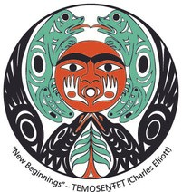

**LE,NOṈET Undergraduate Bursary Application**

Completed applications can be submitted via E-mail: LE,NOṈET Student Leadership Coordinator Office of Indigenous Academic and Community Engagement First Peoples House, Room 144, University of Victoria

Tel: 250-472-4004 | Email: [lenonet@uvic.ca](mailto:%20lenonet@uvic.ca)

|  |  |
| --- | --- |
| Name: | V# |
| Letter of introduction (100-500 words) outlining Indigenous ancestry.  *\*As a helpful tip, think of how you would introduce yourself to an Elder.* | |
|  | |