PAAS 302/501: Literary and Cultural Theory in Pacific and Asian Languages and Literature

Instructor: Angie Chau
Email:
Phone:
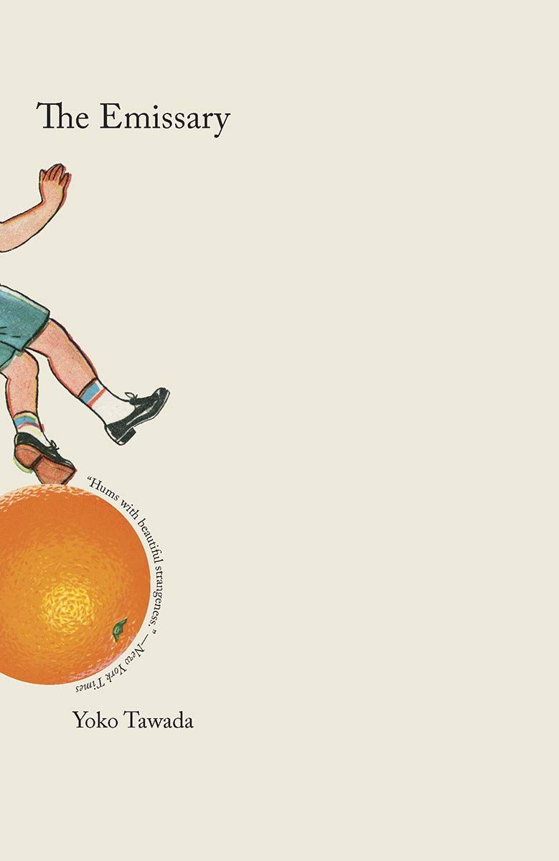
Book cover, Yoko Tawada’s The Emissary, English translation by Margaret Mitsutani

Course description:
This core course examines key theoretical formulations in the recent debates surrounding the politics of world literature, particularly as they apply (or do not) to the context of Asian literature, and on a larger scale, contemporary literature as a whole. We will track various approaches taken in comparative literary and cultural studies, and study of some of the most prominent scholarship related to the discussion of world literary systems, popular culture, sinophone literature, translation, globalization, literary prizes, and cultural identity. We will also read a selection of contemporary Chinese, Korean and Japanese novels in English translation that best illuminate and challenge these theoretical approaches.

Proposed assignments:

Proposed assignments:
Attendance, Participation 20 %
Reading Log 20%
Mid-term exam 20%
Wikipedia project 40%
Final Paper 25%

Proposed reading list:
Culler, Jonathan. Literary Theory: A Very Short Introduction (2011)
Fang Fang. Wuhan Diary (2020)
Han Kang. The Vegetarian (2007)
Tawada, Yoko. The Emissary (2014)
Additional selected theoretical readings

