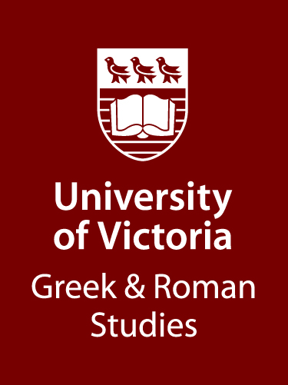 | NOTICE TO STUDENTS IN  GREEK AND ROMAN STUDIES  The Margareta von Rudloff Travel Assistance Fund
The Department of Greek and Roman Studies invites applications for awards from The Margareta von Rudloff Travel Assistance Fund. One or more of these awards may be made annually on the basis of application to the Department. The funding for this award comes from an endowment generously provided by Mrs. Margareta von Rudloff of Victoria. This award is dedicated to supporting travel needs for graduate or undergraduate students taking their degrees in Greek and Roman Studies, by providing funds to deliver papers at conferences, to participate in special academic programs including archaeological excavations, and to visit libraries, museums, and classical sites.

Applications should be submitted to Dr. Brendan Burke, Chair, Department of Greek and Roman Studies by March 15, 2025 (grschair@uvic.ca). The results of the competition will be announced before the end of March 2025. Preference will be given to students majoring in Greek and Roman Studies and those who have not already received an award from this fund.

Students should indicate on their applications if they wish to apply for both the von Rudloff Travel Award and the Murphy Award.
Applications should consist of a letter explaining the purpose, date, and estimated cost of the trip envisaged, including a statement of approximately 250 words, describing the project and indicating what the applicant hopes to accomplish through the travel.
Brendan Burke
Chair, GRS

