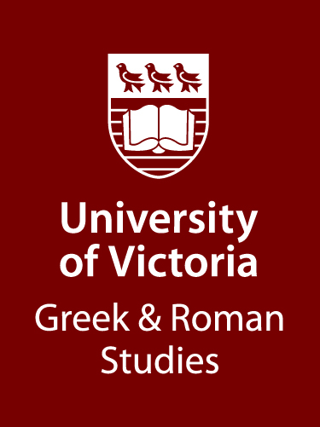 | NOTICE TO STUDENTS IN  GREEK AND ROMAN STUDIES  The Robert J. Murphy Travel Award  in Greek and Roman Studies
The Department of Greek and Roman Studies invites applications for awards from the Robert J. Murphy Travel Award in Greek and Roman Studies. One or more of these awards of at least $1000 may be made annually on the basis of application to the Department. The income from this generous award is dedicated to supporting travel needs for undergraduate students who have a declared degree in Greek and Roman Studies; the award provides funds to assist financially students who are enrolled in a field school, study tour or a study abroad course offered through the Department of Greek and Roman Studies, or approved by the Department.
A limited amount of funds will be available. Applications should be submitted to Dr. Brendan Burke, Chair, Department of Greek and Roman Studies by March 15, 2025 (grschair@uvic.ca). The results of the competition will be announced before the end of March 2025. The Department reserves the right to make a single award, two or more separate awards, or no award at all, if the number or quality of applications is deemed insufficient.
Students should indicate on their applications if they wish to apply for both the Murphy Award and the von Rudloff Travel Award.
Applications should consist of a letter explaining the purpose, date, and estimated cost of the trip envisaged, including a statement of approximately 250 words, describing the project and indicating what the applicant hopes to accomplish through the travel.
Brendan Burke
Chair, GRS

