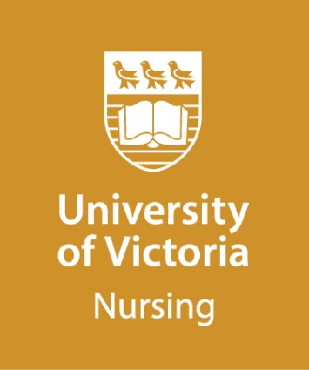
MASTER OF NURSING (MN)

Nurse Educator
Guidelines for Personal Statement

(Maximum 500 words)

The personal statement is an important part of the application process and provides a formal sample of the applicant’s writing. The development of the personal statement provides an opportunity for the candidate to reflect upon their preparation and goals in pursuing their Master of Nursing, in the Nurse Educator option.

The personal statement provides the selections committee with evidence of the applicant’s knowledge, commitment, and experience towards the pursuit of the MN – Nurse Educator degree.

Your personal statement, in narrative form, should clearly address the following questions in detail (point form is not acceptable):

- Reflecting on your clinical experiences and your experiences as an educator, describe your interest in pursuing a Master of Nursing, with an education focus.

- Identify your short and long term goals for graduate education.

- What nursing issues, problems or questions are of most interest to you as you consider pursuing graduate studies in this program option?

- To date, how would you describe the perspective that guides your professional practice?

- Please indicate what course(s) you have taken in statistics and provide the dates of enrolment and course completion.

(Optional: Attach a SHORT sample of your professional or academic writing to your personal statement if you wish, i.e. excerpt from journal article, formal report, etc.).

Please submit your personal statement with your online application.

If you have any questions about your population of focus, please contact the NUED Program Coordinator via gradnurs@uvic.ca , prior to submitting your application.
Personal Statement

Personal Statement (continued)

