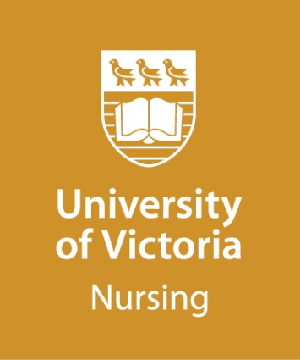
MASTER OF NURSING (MN)

Advanced Practice Leadership

Guidelines for Personal Statement

(Maximum 500 words)

The personal statement is an important part of the application process and provides a formal sample of the applicant’s writing. The development of the personal statement provides an opportunity for the candidate to reflect upon his/her preparation and goals in pursuing a Master of Nursing degree in the Advanced Practice Leadership option.

The personal statement provides the selections committee with the evidence of the applicant’s knowledge, commitment and experience towards the pursuit of the MN degree - Advanced Practice Leadership option.

Your personal statement should clearly address the following questions in detail (point form is not acceptable):

- Reflecting on your practice experiences and the goals of the Master in Nursing - Advanced Practice Leadership option, describe your interest and focus in a particular clinical practice or leadership area and how this focus is related to the goals of the program. Clearly identify your patient/family/community/ population of focus. As teaching nursing students and educating colleagues are not considered clinical populations, please see information on the Nurse Educator option if Nursing Education is your primary interest area.
- What issues, problems or research questions are of most interest to you as you consider pursuing graduate studies in this program option?
- What has led you to apply for this particular graduate program option as opposed to other graduate program options?
- Please indicate what course(s) you have taken in statistics and provide the dates of enrolment and course completion.

(Optional: You may attach a SHORT sample of your professional or academic writing to this personal statement if you wish, for example an excerpt from a journal article, formal report, etc.).

Please submit your personal statement with your online application.

If you have any questions about your population of focus, please contact the APL Program Coordinator via gradnurs@uvic.ca , prior to submitting your application.

Personal Statement

Personal Statement (continued)

