Request your current year Termination Account payout http://www.uvic.ca/hr/forms/index.php

Review your leave balances

This quick guide describes how to check your annual allotments and leave balances.

Access MyPage using your smart phone, tablet or PC.

# | Instructions | Screenshot
1 | Sign in to UVic using your NetLink ID and password. From the My online tools menu, choose My page. | 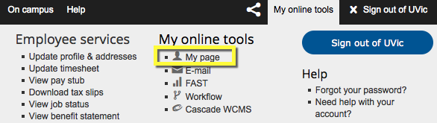
2 | From the left menu bar, choose Employee services. | 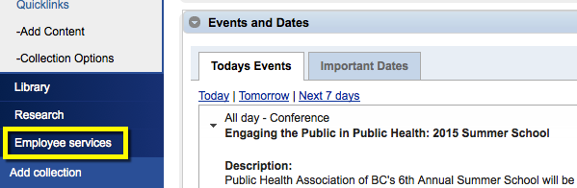
3 | Choose the Leaves & Benefits tab. | 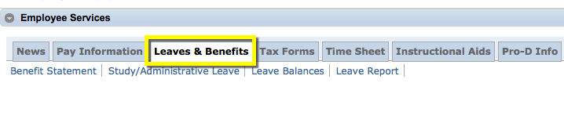
4 | To view your current leave balances, choose Leave Balances. | 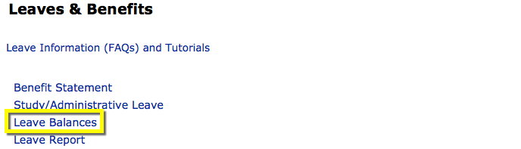
5 | The Leave Balances report shows any leave balances carried over from the previous year, as well as your current allocation, leaves taken to date and available balances. | 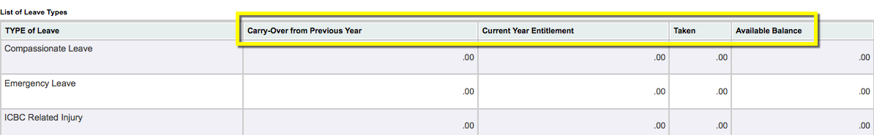
6 | Many types of leave display a negative figure (e.g. -7.0) when leave is taken.  Only leaves with accrued balances (e.g. vacation, sick leave) display a positive balance. | 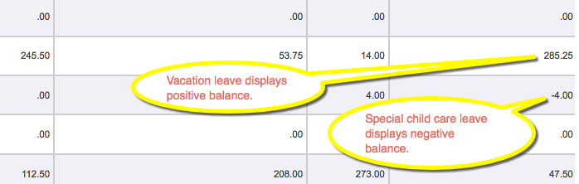

Quick Links:

Collective Agreements http://www.uvic.ca/hr/services/home/labour-relations/index.php
Leaves and Vacation http://www.uvic.ca/hr/services/home/compensation/leaves/index.php
HR Forms and Resources http://www.uvic.ca/hr/forms/index.php
Benefit Handbooks and Quick Reference Guides http://www.uvic.ca/hr/services/home/compensation/benefits/handbooks/index.php

