Web leave entry
Quick Guide

Employee web leave entry

This quick guide describes how to create and submit a monthly leave report using My page. It describes how to enter and copy hours for various kinds of leave (e.g. vacation, sick time), how to enter comments and submit a leave report for approval.

You will receive an email request to submit your leave report on the first day of each month and are encouraged to submit it within 7 days. If you do not have leave time to report you still need to submit a leave report each month. You can view your own leave reports for the previous 18 months.

For more information about leave management at UVic, visit www.uvic.ca/hr/services/home/compensation/leaves/leave-management/index.php.

# | Instructions | Screenshot
1 | Sign in to UVic using your NetLink ID and password. From the My online tools menu, choose My page. | 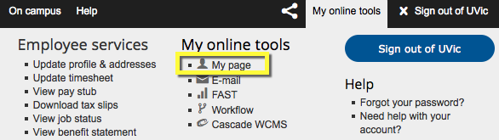
2 | From the left menu bar, choose Employee services. | 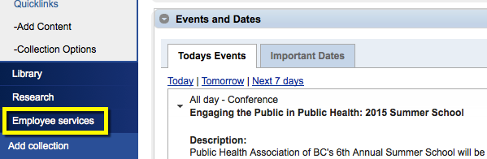
3 | Choose the Leaves & Benefits tab. | 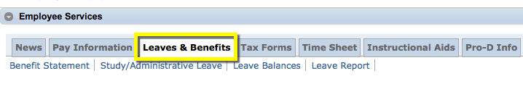
4 | To view your current leave balances, choose Leave Balances. | 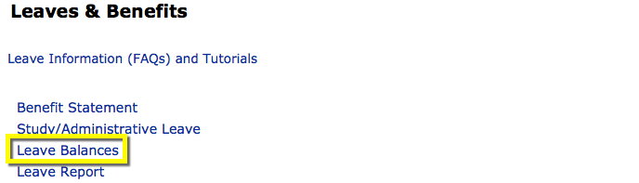
5 | The Leave Balances report shows any leave balances carried over from the previous year, as well as your current allocation, leaves taken to date and available balances. | 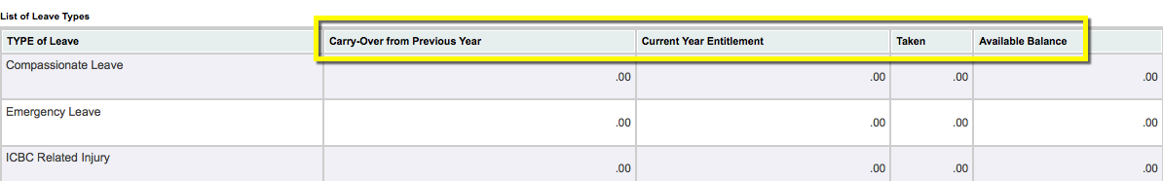
6 | Many types of leave display a negative figure (e.g. -7.0) when leave is taken.  Only leaves with accrued balances (e.g. vacation, sick leave) display a positive balance. | 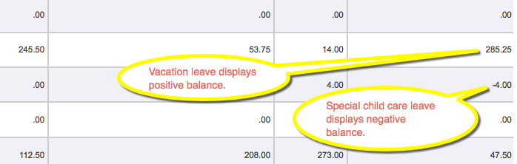
7 | To submit your monthly leave report, choose Leave Report from the Leaves & Benefits tab. | 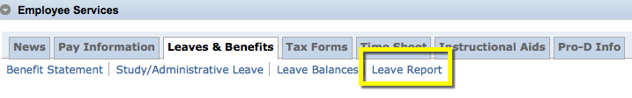
8 | Click on the dropdown arrow to choose the monthly Leave Report Period. A new leave report will display the status Not Started. A report waiting for approval will display the status Pending.  Choose the Leave Report button.  TIP: If you are an approver you will see a different screen than in this screenshot. See the Approver web leave entry guide for details. | 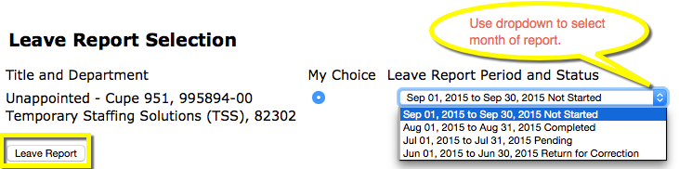
9 | The monthly leave report displays one week at a time. Types of leave are listed on the left, while dates appear at the top. | 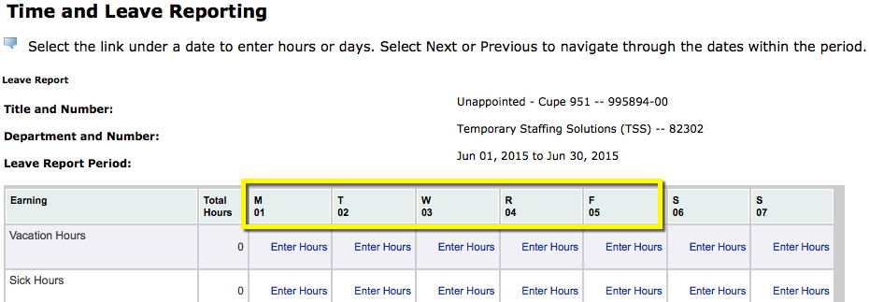
10 | To move to the next week, choose the Next button below the table. | 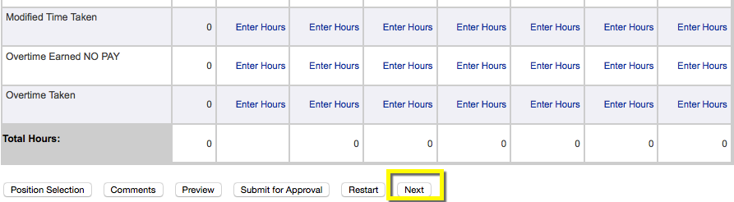
11 | To enter leave that you have taken, find the date and type of leave, and click on the Enter Hours hyperlink. Enter the number of hours taken in the field above the table.  In this example, the employee has recorded 7 hours of sick time for June 3.  TIP: CUPE and Exempt Support Staff must enter sick, vacation, dependent sickness, special leave and long service leave in 3.5 or 7.0 hour blocks. Enter all other leaves as taken. | 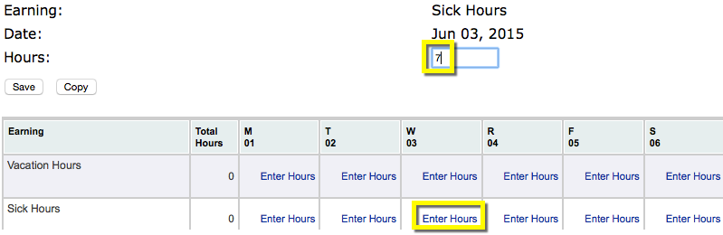
12 | If you are entering leave for a single date, choose the Save button and go to Step 17.
13 | If you took the same number of hours on more than one day, you can copy the hours taken.  Enter the number of hours in the field above the table. Choose the Copy button.
14 | On the date screen, check the box(es) below the applicable dates for the month.  TIP: Do not check the box for the original date. If you do it will be deselected. | 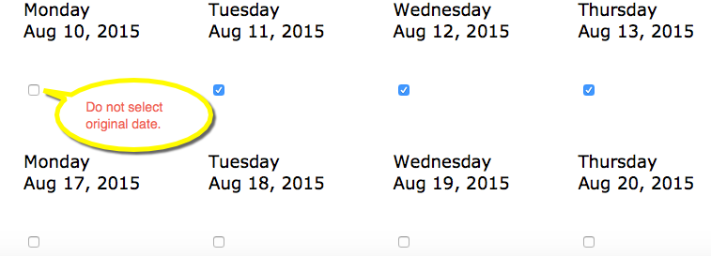
15 | Choose the Copy button at the bottom of the screen. When you are finished copying, choose the Leave Report button.  The copied hours will now appear on your leave report. | 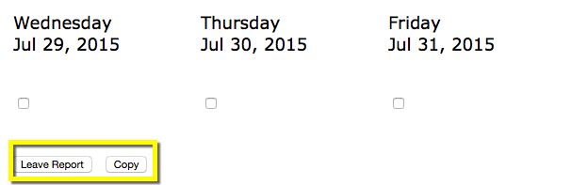
16 | Follow the same process to enter all of your leave for the month.  In this example, the employee is recording 3.5 hours of emergency leave.  Enter the number of hours in the field and choose Save. Or copy the hours to other dates if applicable. | 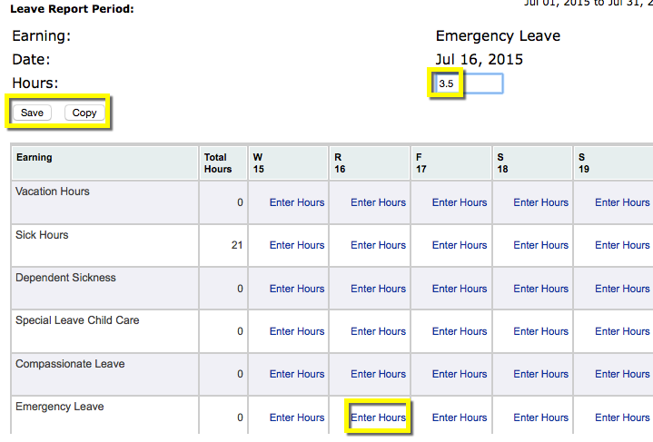
17 | You may see an advisory regarding Possible Insufficient Leave Balance.  Check your leave balances for accrued leave (e.g. vacation, CUPE/Exempt Support Staff sick time) to ensure you have sufficient time available. | 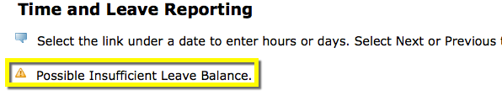
18 | If at any point you wish to clear the hours you have entered and start again, choose Restart. | 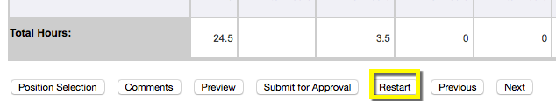
19 | If you wish to add a comment to one of your entries, choose Comments. | 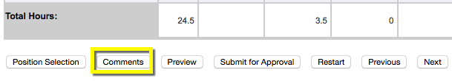
20 | Type your comment in the field, and include the applicable date. Choose Save. Choose Previous Menu to return to the report. | 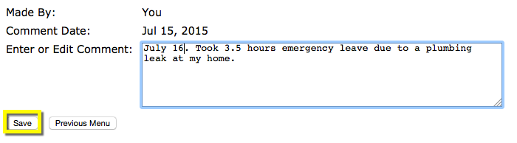
21 | When you have finished entering your leave hours, choose Preview to review your leave report. | 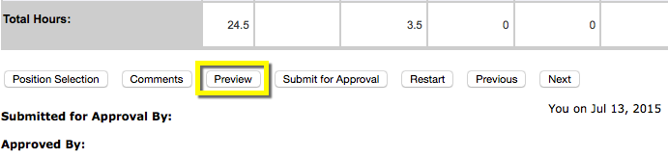
22 | Check that all dates, times and comments are correct. | 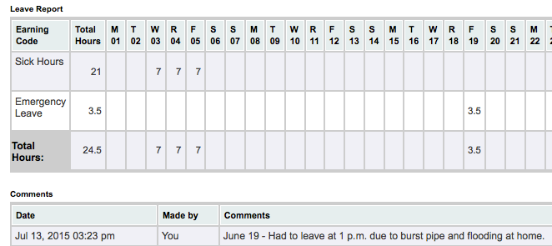
23 | To correct or submit your report, choose Previous Menu. | 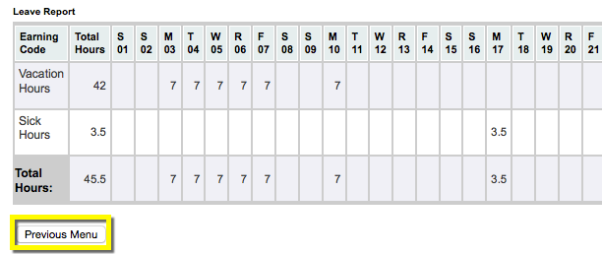
24 | If the month is not yet complete, choose Save. You will be able to return later to enter additional hours.  TIP: Do not submit your report for approval until the last day of the month, in case you need to make changes or adjustments. | 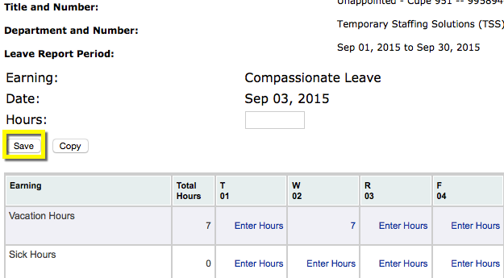
25 | The next time you log in, your leave report status will show as In Progress. You can enter additional hours before submitting your report for approval. | 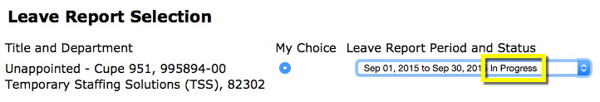
26 | When you are ready to submit your report, choose Submit for Approval. | 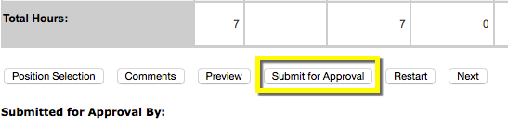
27 | A confirmation message will appear to show the date your report was submitted and the name of your supervisor.  TIP: Your leave balances will not be updated until your supervisor has approved your outstanding reports. Supervisors receive reminder emails regarding leave report approvals on the 15th and 25th of each month.
28 | If you have not taken any leave time you still need to submit a leave report each month. When you receive a reminder to submit your report, locate the appropriate leave month and choose Submit for Approval without entering any hours.
29 | You will receive a confirmation message that your report has been submitted successfully.  TIP: Your supervisor must approve your leave report every month, even if you have not taken any leave. | 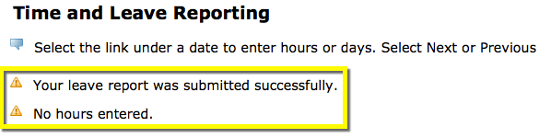
30 | If you need to change your report after submitting it for approval, contact your supervisor.  He or she can return the report to you for correction.  Edit the report. Then resubmit it to your supervisor for approval. | 