JOB DESCRIPTION FORM FOR CO-OP EMPLOYERS
CO-OP WORK TERM | ☐ SUMMER (May - Aug) |  | ☐ FALL (Sept - Dec) |  |  |  | ☐ SPRING (Jan - Jun)
ORGANIZATION | [Enter Organization Name]
POSTING OPENS | [Start date that the job posting is visible to students in the Co-op Portal]
POSTING CLOSES | [We recommend closing after 10 days to allow students time to apply]
CO-OP WORK TERM DURATION | ☐ 4 MONTHS | ☐ 8 MONTHS |  | ☐ 4 or 8 MONTHS |  | ☐ 4 or 8 MONTHS with 8 MONTHS PREFERRED
JOB TITLE | [The more specific to the role, the better!  Typical roles for Health Information Science students include Business Analyst, Clinical Applications Analyst, Go-Live Support, Health Business Consultant, Health Data Analyst and Health Systems Analyst]
SALARY/ WAGE | [Enter Co-op Hourly Wage]
HOURS PER WEEK | [Typical work week hours for a full-time co-op student are between 35 and 40 hours per week. Students must have a total of 420 hours for the work term to meet co-op requirements]
WORK SITE ADDRESS | [The job is performed at a specific address]
WORK ARRANGEMENT | ON-SITE  ☐ Student is expected to work on-site full-time |  | HYBRID  ☐ On-site weekly with flexibility for remote days  ☐ Student can remain in Victoria but may be required on-site occasionally |  |  |  | REMOTE  ☐ Fully remote with no requirement to be on-site  ☐ Remote with initial on-site training or equipment pickup
 | [Provide additional work arrangement details if required]
NUMBER OF POSITIONS | [Indicate how many students you hope to hire]
JOB DESCRIPTION | [Provide a job summary and description]
QUALIFICATIONS | [Provide specific competencies (e.g. teamwork, analysis)]
VACCINATION STATUS  Does the student need to be vaccinated for COVID-19? | ☐ YES – vaccination required |  |  |  | ☐ NO – vaccination not required
SPECIAL JOB REQUIREMENTS | [Provide any specific requirements here.  Examples may include:  - Having a driver’s license  - Travel may be required  - Working evenings or weekends during a site activation]
For relevant employers as defined by the BC Criminal Review Act: Will this position require a co-op student to complete a Criminal Records check?  ☐ YES ☐ NO |  |  | Is the position open to International students with a valid Co-op work permit?  ☐ YES ☐ NO
CO-OP STUDENT TYPE | ☐ GRADUATE  Nursing Informatics and HINF Grad students |  |  | ☐ UNDERGRADUATE
TARGETED  PROGRAM AREAS | ☐ JOB OPEN TO HINF PROGRAM STUDENTS ONLY
☐ JOB OPEN TO OTHER DISCIPLINES
[Please list which programs this job posting is open to in this section. For example, your posting may be open to students in health information science as well as computer science and software engineering]
APPLICATION PROCEDURE | ☐ UVic Posting System - students apply using the Co-op portal and applications are sent to the employer on the closing date.  ☐ Employer Email - students apply directly using the employer email address. Please provide an email address if selecting this option ________________  ☐ Employer Website - students apply through an employer portal. Please include a link to the employer application site ____________________
APPLICATION MATERIAL REQUIRED | ☐ COVER LETTER | ☐ RESUME |  | ☐ TRANSCRIPT |  |  |  | ☐ REFERENCES
ADDITIONAL APPLICATION INSTRUCTIONS | [Provide any special application instructions here. For example, you may have a specific person the cover letter should be addressed to.]

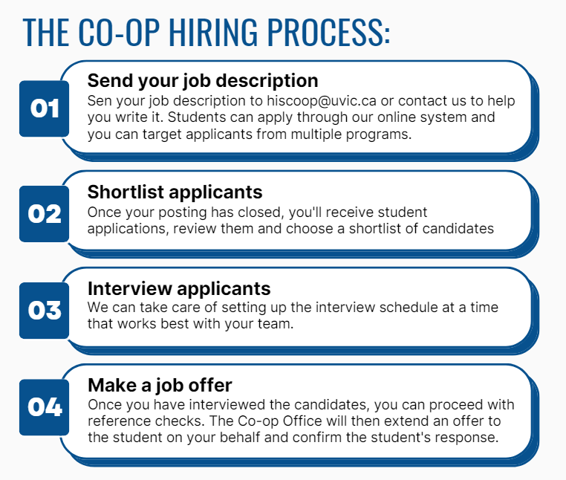

A few points to consider:

- For a work term to meet the co-op specifications, it needs to be a minimum of 12 weeks
(420 hours) which is the equivalent to working 3 months out of a 4-month period.

- Most co-op work terms are 16 weeks and coincide with our regular semester system (Jan-Apr, May-Aug, Sept-Dec).

- It is also best to secure organizational funding and approvals prior to beginning the process of securing a co-op student placement. If a student applies, interviews and is selected, only to find out that the position is not going forward, this can delay their academic plans, graduation date, etc.

Thank you for supporting the University of Victoria's co-op education program!
 | Jason Bond  Co-op Coordinator  School of Health Information Science  Co-operative Education Program and Career Services  University of Victoria  hiscoop@uvic.ca  250-721-8577

