NSERC CGRS D Fall 2025

How to Apply to the UVic Competition

1. Visit [Canada Graduate Research Scholarship – Doctoral](https://www.nserc-crsng.gc.ca/Students-Etudiants/PG-CS/cgrsd-besrd_eng.asp)
2. Select the link for **NSERC Online system**
3. Select **Form 201 – (CGRS D & CPRA)**
4. Select **Option C** or **Option D**
5. For institution, select the **List** button, **CGRS D** program, Province of **British Columbia**, and **University of Victoria** from the list of options.

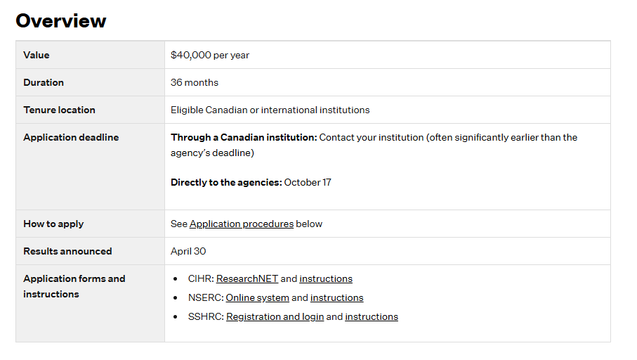

Screenshot of NSERC Online System section where an applicant selects Form 201 - CGRS D & CPRA to initiate a doctoral scholarship application.

