Facilities Management
Guiding Principles
to Client Billing
(September 2019)

Table of Contents
Table of Contents 3
Guiding Principle: 5
Key Principles: 5
Academic and Administrative Buildings 5
Agencies 6
Ancillary Services 6
Work Order Billing 7
Billing Types 8
General Maintenance 8
Customer Funded 8
Self Funded 8
Agency - Non-UVic units 8
UVSS/GSS – University of Victoria Students’ Society and Graduate Students’ Society 9
Accounting References 9
Billing Guidelines Based on Types and Sub Types 10
Custodial Services 10
Interior Modification Services 10
Internal Distribution 11
Project Services 11
Special Events 11
Waste and Recycling 11
Standing Work Orders 11
Project Operations 12
Project Support 12
PM – Preventive 12
Miscellaneous Types and Sub Types 12
Work Order Activity Groups: 13
Demand Maintenance: 13
Preventative Maintenance: 13
Project Work: 13
Frequently Asked Questions: 15
References 16

Guiding Principle:
The Vice President Finance and Operations (VPFO)’s Office approves the Facilities Management hourly service rates and establishes billing practices/guidelines. The Facilities Management Service Rates are posted on the Facilities Management website.
The Customer Service Team, reviews all requests for service and applies these guidelines based on the information presented in the work request. Questions regarding service charges to departments can be directed to the Director of Customer Service and Program Integration or the Director of Finance and Administration.

Key Principles:
- The VPFO (Budget Office) approves the hourly services rates as recommended by the FMGT Director of Finance and Administration.
- Billing practices are to be consistently applied across campus and over time.
- The Account Code on the Asset, and the account used by the customer on a demand work request are the primary factors for determining the correct billing type.
- Core services are critical for University operations and decisions about the service are made centrally by Facilities Management (FMGT).
- Utilities, custodial services, grounds maintenance, the maintenance of heat, water, electricity, and air quality systems are examples of cores services.
- Core services are centrally funded – FMGT operating budget.
- Supplementary Services are tasks that are requested at the discretion of the department.
- The repair and maintenance of equipment unique to the program offered by the department, such as research and athletics equipment, is supplemental.
- The cost of providing Supplementary Services are recovered from the department.

Academic and Administrative Buildings
- The Maintenance of Academic and Administrative buildings is base budget funded and Facilities Management receives an annual operating budget for core services, routine and ongoing maintenance.
- New Installations initiated by the department, Special Events and Supplemental Services are Client Funded in Academic and Administrative Buildings.
- Repairs of equipment or assets that are a part of the building are General Maintenance in Academic and Administrative Buildings.

Agencies
Agencies are units that operate at the University, that have their own governance structure, and do not report to the University administration.
- The University of Victoria Students’ Society (UVSS) have exclusive use of the Student Union Building as does the Graduate Students’ Society (GSS) of the Halpern Centre for Graduate Students (GSS). These students’ societies have a unique billing type (Billing type: UVSS_GSS) for core services that would typically be billed as General Maintenance in an Academic and Administrative buildings.
- The UVSS and GSS use the Agency billing type for new installations and supplemental services.
- The University Club always uses the Agency Billing type.

Ancillary Services

- Ancillary Operations are business like units that report to the University Administration, are self funded and do not receive funding from the central university budgets.
- The cost of providing both core and supplemental services are fully recovered from ancillary operations.

Work Order Billing

There are five billing types in FAMIS Cloud that are applied to client requests for service. These billing types are applied strictly on the FUND segments of the account code. The FUND segment determines if it is Customer Funded, Self Funded, or Agency billing type. The nature of the work requested determines if the General Maintenance or UVSS_GSS billing type is used.
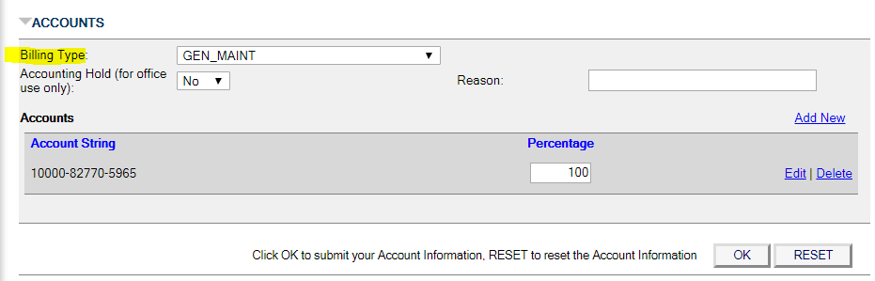
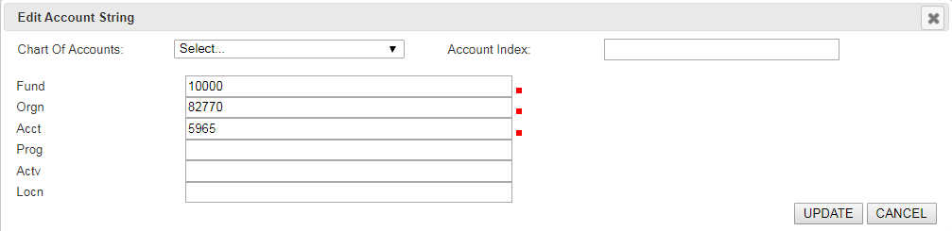

Billing Types

General Maintenance
- No charge to requestor/building occupant.
- General routine maintenance and repairs for Academic and Administrative Buildings and the grounds areas not associated with agency or ancillary operations.
- Accounting Index: FMGM
- Account Code: 10000-82770-5965

Customer Funded
- Charged to requestor at the rate that does not include employee benefit recovery.
- All departments using operating fund accounts starting with 10000.
- Requests from administrative/academic units for supplemental services.
- Supplemental services for research units such as the Animal Care Unit or the Outdoor Aquatics Centre.
- Athletics Services (ATRS) include the Ice rink at Ian Stewart Centre, Athletics Stadium, and some playing fields and athletics equipment are generally client funded. All Demand work orders are client funded for all Athletics areas for programmatic assets. The Stadium is always 100% client funded as is the Ice Rink for all work orders.
- Always starts with 10,000 for the FUND

Self Funded
- Charged at the rate that does include employee benefit recovery.
- Ancillary Operations.
- Units with a 20000, 30000, 40000, and 70000 account code in the FUND
(account string first number):
  - See page 10 for further details.
- Bookstore / Coffee Shop.
- Childcare Services.
- University Food Services.
- University Residence Services.
- Campus Security, Parking and Transportation Services: maintenance work for parking lots / parades / bike lockers.

Agency - Non-UVic units
- Client is requesting a service to be provided or asking for something “new”.
- Units with a 90000 account code in the FUND (first number in the account string),
- UVSS/GSS work that is supplementary and the University Club.
- Units occupying a small space of office are not charged for building maintenance. Such spaces include University Houses and the Chapel, among other smaller units around campus.

UVSS/GSS – University of Victoria Students’ Society and Graduate Students’ Society
- Client is requesting something be repaired.
- Work in the UVSS and GSS that would be considered General Maintenance in an Academic or Administrative building.
- Requests related to basic building maintenance and repairs are discounted by 51% (of the Ancillary rate) according to the Terms of Reference GSS and UVSS /UVic Operational Relations Committee.

Accounting References
University Funding Types
Fund | Type of Funding
10xxx | General Operating
20xxx | Ancillary Enterprises
3xxxx | Sponsored Research
4xxxx | Specific Purpose
61xxx | Endowment
7xxxx | Capital Projects
9xxxx | Agency (Non-UVIC)

Billing Guidelines Based on
Types and Sub Types
The following list of Types and Sub Types indicate a general rule of thumb for client charge backs in Administrative and Academic buildings based on types and sub types. Where the billing is denoted as “Client Funded” (billing types other than General Maintenance) the actual billing type is determined by the FUND account string as denoted in the chart on page ten “University Funding Types”.

Custodial Services
- Custodial Services – Client Funded
  - Move In / Move Out related work.
  - Additional Carpet Cleaning Requests.
    - Outside of regularly scheduled cleaning.
  - Special (Additional) Cleaning requests
    - Post project work cleaning is client funded on the project account.

- Custodial Services – General Maintenance
  - Carpet / Upholstery Cleaning – maintenance or spot cleaning.
  - Clean Up: Hazardous Spills, Non-Hazardous Spills, and Plugged Toilet.
  - Floods / Restocking Restrooms.
  - Follow up work for Janitorial Runs.
(work missed or not done to APPA standards)

Interior Modification Services
- Interior Modification Services – Client Funded
  - All items under this type go directly to the Manager of Interior Modification Services (MODS) for review, including repair of furniture and bookshelves.
  - New bookshelves must meet UVic Standards and therefore go through this division for initial review.
  - If the MODS team requires repair of the items sent to this team to be completed by the shops, this work needs to be updated to General Maintenance billing type and deemed a Repair now as it is part of base funded buildings items.

Internal Distribution
- Internal Distribution - Client Funded
  - Box Moves and Interdepartmental Furniture Moves
  - Project Surplus Furniture - project covers the cost of disposal and moving of those item, due to the volume of work usually required

- Internal Distribution – General Maintenance
  - Surplus Furniture, including the moving of that surplus furniture moves for Facilities Management internal units
  - Internal delivery for Facilities Management units

Additional Note:
- Surplus Asset Coordinator - Surplus Sales – related work orders are always client funded

Project Services
Project Services – Client Funded
- Requests for project work through Self Serve Portal

Special Events
- Special Events – Client Funded
  - Waste and Compost Bins,
  - Furniture Rentals
  - Utilities connections

Waste and Recycling
- Waste and Recycling – General Maintenance
  - Exception – Ancillary and Agencies pay for all services

Standing Work Orders
- Standing Work Orders – as per work order account
  - Horticulture and Landscape Crews perform most of their work on Standing Work Orders for tracking purposes.
  - Exceptions Ancillary Services pay for their services.
  - SUB & GSS pay reduced fee for their services. (UVSS_GSS Billing type)
  - Irrigation services are General Maintenance for the entire Campus.

Project Operations
- Operation projects are funded as per direction of the manager or director.
- Usually client funded (Self Funded, Customer Funded, or Agency) but may also be general maintenance in some cases (such as Classroom Accomodations).

Project Support
- Project Management –
  - Project Management Services used the shops for project support.
  - It is important to put the Project “F” number and location code into the accounting string.

PM – Preventive
- Preventive Maintenance work orders are funded as per the account string on the asset being serviced.

Miscellaneous Types and Sub Types
Adjust, Install / Uninstall, Repair – Various funding as per guidelines below

- The rule of thumb is that the Asset is the true source of accounting.
- A Second Rule of Thumb, if it is new equipment installed at the request of the department the charge is Client Funded, if it is a building system repair, it is General Maintenance for Academic and Administrative buildings.
- Research related and program specific assets are usually Client Funded
  - Animal Care Unit, Research Equipment, Computing Services air conditioners.
  - Outdoor Aquatic Unit shares the costs of maintaining that facility with Facilities Management. There are some assets in that facility that are solely funded by their research accounts but for the most part assets are funded by the following shared account: 10000-82426-9250-00400; therefore, it is very important to always check the asset accounting when charging for services in the Outdoor Aquatic Unit.
  - Glover Greenhouse Facility is a base funded building however, the department pays for the maintenance of the research equipment such as the Growth Chambers.

Work Order Activity Groups:
Demand Maintenance:
Work orders in the form of work requests come from Self Service users or are created from information received verbally or electronically and entered into FMIS. The demand work order process includes both work requests and standing work orders and the priorities are set to reflect the work requested. The system defaults work request work orders with an activity of demand.

Preventative Maintenance:
Work orders are created by FMIS for repeatable routine maintenance and inspections when selected to “generate schedule” in the schedule module. Preventative maintenance system generated work orders may contain a single asset or multiple assets depending on the work plan built into the scheduling module. All work orders generated by the scheduling module are assigned an activity group of Preventive by the system.

Project Work:
Project work orders are created in the work request screen with information provided by the project manager and configured following the parent child methodology. Project work orders may be operating maintenance or capital improvement and are unique to each project by their account codes.
The initial priority for all Operations project work orders is selected as pending until scheduled into the overall work order system backlog and the activity is set to project.
The initial status for all Project Management Services project work orders is selected as “Open” and assigned to the Project Manager.
Project Work Orders – Residence Services (RESS)
All RESS projects are to use the Account String 20021-81774-9236-F3-C3 to indicate that this is the construction phase funding of Residence projects.
Standard Project Set Up:
PROJECT NUMBER / PM: 19-0xxxx
ACCOUNT: 20021-81774-9236-F0xxxx-C3
PARENT ID:
SHOP(S) REQUEST:
Service request for
SCOPE OF PROJECT (BRIEF):
LOCATION:
SCHEDULE DATE:
CLIENT CONTACT:
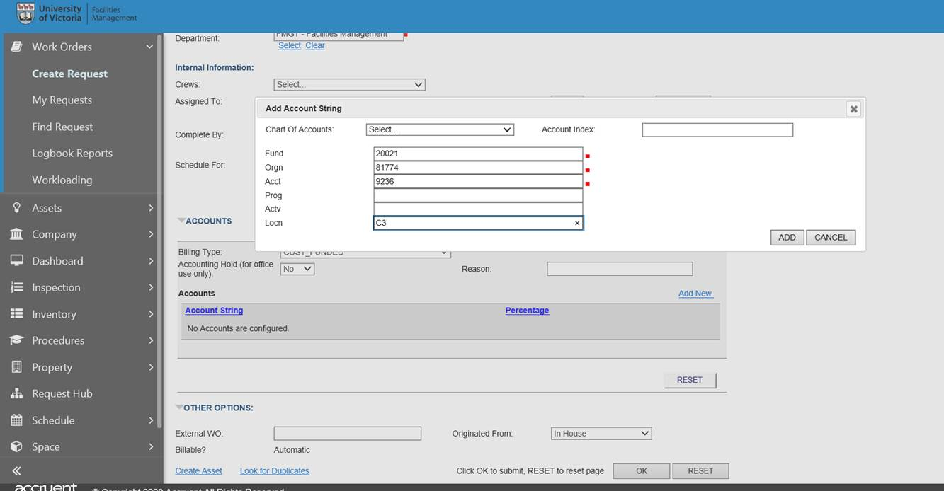
ACTV – F#
LOCN –

Billing Key Exceptions:
- Stadium – All Service Requests – Customer Funded
- Playing Fields Demand Service Requests – Customer Funded
- McKinnon Gym and CARSA – Base Funded Buildings
  - Pay for Programmatic Work Requests such as repairs to gym equipment or areas where clients pay to enter
- Accessibility Lifts – Usually in Washrooms, Change Areas – General Maintenance
- Furniture Accommodations
  - Classroom Accommodations – General Maintenance
  - Office Accommodations (non-classrooms) – Client Funded
- Residence Services
  - Preventive Maintenance Work Orders and Asset Accounts use the Sub Code 9250
  - Demand Work Orders use the Sub Code 9256
- Sub Code application for the ACCT component of the FOAPL Account String:
  - All Demand Work Orders except where noted below – 9250
  - Distribution Service and Waste Reduction – 9256
  - Projects – 9236 – always except for Agencies
  - Agencies – Always – 7351 – even Projects
  - Residence Services Demand Work Orders - 9256

Frequently Asked Questions:

- What happens is that we have “Agency” accounts “90,000” codes sprinkled throughout campus in buildings that the university funds (base-funded buildings). University House 1 is one of those buildings?
In these cases, we do not charge Agency rate for repairs, but we do charge Agency rate for “new” installations and supplemental services. Building repairs are under General Maintenance.
- Who pays for Accessibility Furniture across campus?
Accessibility Furniture for students is always billed to General Maintenance, regardless of the building or space (even UVSS / GSS). Furniture for employees is recoverable from the department.
FMGM – The cost of furniture loans for student accessibility requirements are not recoverable from the department associated with the building or the CFAL.

- Who is responsible for Street Signs and Road Signs?
Campus Security is responsible for all signs in all parking lots. They replace them and Facilities management has nothing to do with it unless a request comes in for assistance (usually a new post). Therefore, call the Manager of Parking and Transportation Services at Campus Security and provide all pertinent details and then cancel the work order.
Road Signage is repaired and installed by Horticulture who will request support from other facilities management Shops, if and when required.

- Who pays for power washing?
Most power washing is done by the Landscape crew.
As this item is requested by the client, it is client funded.

- Campus Security often does training sessions on Fires Extinguisher use. Who pays for this?
As fire and safety are the key responsibilities of Campus Security and Facilities Management (FMGT), FMGT provides fire extinguishers to Campus Security free of charge to provide Fire Extinguisher Training to the campus. Therefore, this is a General Maintenance item.

- What does Athletics and Recreation Services pay for?
The cost of utilities and maintenance of the Centennial Stadium (Building #128) and the Ice Rink in the Ian Stewart Complex (Building #125 – Rooms 101F, 102, 105, 107, 201, 241 through 259, 301E and 301F) is the responsibility of Athletics and Recreation Services.
Athletics and Recreation Services is responsible for the cost of maintaining athletic equipment, including the CARSA Hydro therapy pools and climbing walls.

References
- Standard Operating Procedures
  - 1.1 SOP Work Order Activity Types
  - 1.2 SOP Work Order Billing Types
  - 1.3 SOP Recording of Information on Work Orders
  - 1.4 SOP Work Order Supervisory Oversight
  - 1.5 Work Order Priorities
  - 1.6 Work Order Scheduling
  - 4.1 SOP Elevator Callouts
  - 4.2 SOP Off Hours Breaker Reset
  - 4.5 Graffiti Removal
  - 5.1 SOP Interdepartmental Charges

