CIVE Laboratory and Graduate Student Offices
Request for Access During COVID-19 Closure

Because of the COVID-19 virus, all CIVE laboratories and graduate student office spaces are closed until further notice. Exceptions will be considered on a case-by-case basis, and only with special arrangements that adequately account for both virus-related and general laboratory health and safety risks. To request lab or office access, please provide the following information.

Submit your completed form to Armando Tura <atura@uvic.ca>, Lab manager, with copies to your research supervisor, or contact Armando for Chris Kennedy <cakenned@uvic.ca>, Department Chair, if you have any questions.

Contact Information
First Name: Click or tap here to enter text. | Last Name: Click or tap here to enter text.
Email: Click or tap here to enter text. | Phone: Click or tap here to enter text.
Research Supervisor: Click or tap here to enter text.

Emergency Contact
Name: Click or tap here to enter text.
Relationship to you: Click or tap here to enter text.
Email: Click or tap here to enter text. | Phone: Click or tap here to enter text.

Virus Risk from Personal Activities
Describe your accommodation (type of accommodation, number of people in unit) and transportation situations and your arrangements for physical distancing at home and during your travel to campus:
Click or tap here to enter text.
Describe any potential exposure to the virus you may have had during the past 2 weeks—e.g. travelling, attending crowded events etc.:
Click or tap here to enter text.

Experiment
Experimental work objectives:
Click or tap here to enter text.
Urgency – describe specifics of the urgency (need to complete this work within a given time period):
Click or tap here to enter text.
Requested schedule—estimated hours per day, days per week; total number of days:
Click or tap here to enter text.
Facilities, Equipment and Materials—describe the facilities/lab spaces, equipment, tools, consumables, chemicals, PPE, and potential technical support staff required to perform activities:
Click or tap here to enter text.

Work Plan and Risk Assessment
Describe the activities to be performed, listing each step, in chronological order, and provide a risk assessment of each step:
Be specific in all the aspects that could be of concern in the current COVID-19 climate including: 1) concerns for virus transmission, and 2) general safety concerns. Campus resources are currently drastically reduced and emergency scenarios cannot be handled as they would under normal capacity. A risk matrix is attached to help evaluate the hazards and risks—risk factors under the current conditions should be treated as higher than under normal conditions. Do not overlook that 1) and 2) can compound catastrophically. Attach additional pages if necessary.
Click or tap here to enter text.

StepBack
Look and see the hazards Assess the risk Take appropriate action
Step back 2 meters for 2 minutes
Supervisors Name: | Signature:
Student Names:
Date and Time: | Location:
Description:
1 Look and see the Hazards
Below is a list of common hazards to help trigger you to potential ones you may encounter while doing your job.
2 Assess the Risk

General
- Chemicals handling
- Pressurized Systems
- Fire/explosion
- Hot substances
- Strong magnetic fields/induction
- Electrical systems, high voltage
- Radiation (heat/laser/radioactivity)

Equipment Safeguarding
- Training to operate the equipment
- Exposed rotating parts
- Improper guards
- Interlock bypassed/poor condition
- Pinch points or crushing

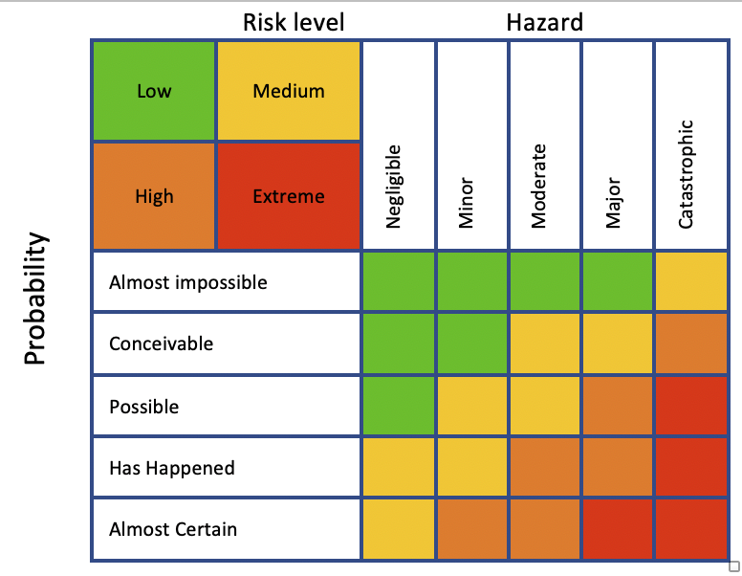
COVID-19
- Does the work involve more than one person
- Does the work require extensive spaces and surfaces
- Is the work area difficult to clearly identify, mark, or constrain
- Is there a high risk of virus contamination
- Am I physically put under stress (impact on immunity system)
- Is the lab difficult to decontaminate, dirty surfaces, etc.
Hazardous Materials
- Extensive accumulation of dust/mist/fumes
- Inadequate information (labels/SDS)
- Improper storage/containment/handling of chemicals
- Sources of ignition nearby

Occupational Health and Hygiene
- Awkward work position
- Lifting, twisting, and/or repetitive movements
- Potential for slips, trips and falls
- Excessive noise/dust
- Physical Overextension
 | Yes | No
- Have we looked and identified all hazards?
- Are we trained and competent to conduct this task?
- Are the resources (equipment, tools, PPE, and personnel) available?
- Have we identified all the hazards since we last did the task?
- Are other persons and the environment protected from our activities in the area?
- Do we know what to do in case of an emergency?
- Do we have safe access and egress to and from the work area?
- Can we do this job without putting ourselves, others or the environment at risk?
- Is our work area clean and tidy?

