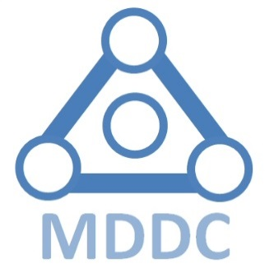

Fourth Annual MDDC Awards
for Excellence in Biomedical Engineering
Student Design & Innovation

Application Form – Submit by 12 midnight on March 18th, 2018
(Email to awards@mddc.org; application will be acknowledged upon receipt)

- Indicate the title of your innovative project: ______________________________
_________________________________________________________________
- Name(s) and affiliations of individual(s) applying (if affiliated with a post-secondary institution, please include faculty(ies) and department(s) or program(s); if affiliated with a company or non-profit organization, please include position/title):
(Name) (Affiliated institution)

___________________________ _____________________________

___________________________ _____________________________

___________________________ _____________________________

___________________________ _____________________________

- Contact information:
Contact name ____________________ Email: __________________________
Contact phone ___________________
Mailing address: ___________________________________________________
_________________________________________________________________

_________________________________________________________________

- Are you aware of the Award Terms and Conditions (as attached below) and do you
accept them? Yes No

- By April 29th 2017 will you have a prototype/project result suitable for demonstration (directly or remotely) to the Awards Selection Committee?
Yes No

- Please describe (2 pages maximum, appended to this application form) how your innovation matches the 5 criteria (as attached) used by the MDDC Awards Selection Committee.

- With your two-page summary you may submit a 3-5 minute video highlighting your project objectives and goals, as well as the problem it solves, a brief introduction of each team member, and a brief demonstration of your concept/prototype.Videos should be uploaded to YouTube, Vimeo or a similar service with a private or public link submitted. Videos can also be shared via Dropbox, Google Drive or similar.

- Process:

Your application will be reviewed upon receipt by the MDDC Awards Selection Committee. Supplementary information may be requested to assist the Awards Selection Committee in completing their evaluation.
A short list of applications will be made, and all short-listed applicants will be invited to demonstrate their project/prototype to the Awards Selection Committee. Demonstrations will be scheduled for April 29th, 2018
Decisions on Award winners will be made immediately upon completion of project demonstrations, and all winning and short-listed applicants will be invited to a special meeting of the MDDC for presentation of Award certificates and cash prizes. All shortlisted applicants who do not win Award certificates and cash prizes will receive Finalist certificates to indicate that the projects made the short list.

This meeting will be held immediately after the project demonstrations on April 29, 2018.
Thank you for participating!
MDDC Medical Device Development Centre
www.mddc.org

