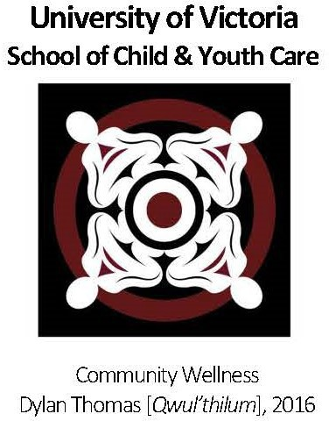APPLICATION FORM

Master of Arts Program

Child, Youth, Family and Community Studies

**\*Please do not exceed the word maximum for each section.*  
Please note: responses that go over word maximums will not be reviewed.**

Please tell us how your background and social location shape your interest in this program: **[200 word maximum]**

Provide a summary of your relevant paid and/or volunteer work experience: **[200 word maximum]**

How has your experience with children, youth, families and/or communities prepared you for this program? **[250 word maximum]**

The CYFCS MA program requires research methods courses and the completion of a research project or thesis. It is, therefore, important that you provide a description of: **[250 word maximum]**

1. your involvement in research projects, including undergraduate theses, research internships, or research assistantships. Highlight any practical experience and skills gained through participation in research projects.
2. research courses you have taken, including research knowledge and skills you have acquired.

This program requires you to have a selected text-based research topic and question(s) that do not involve human participants for the start of the program in September. Please provide your specific research question(s) that you plan to explore: **[250 word maximum]**

Identify one or two specific topics of interest for your Master’s research, including a brief rationale.   
**[100 word maximum]**

Please refer to the list of research faculty on our webpage and identify one or two potential academic supervisors based on your research question(s).

Please describe your key academic and/or professional strengths as related to Child, Youth, Family and Community Studies. **[200 word maximum]**

Please identify key challenges you anticipate facing in a graduate program and the tools and resources you would engage to meet these challenges. **[200 word maximum]**

What are your career goals on completion of this program? **[100 word maximum]**

Do you have any learning accessibility requirements that you would like to share? **[50 word maximum]**

We invite Indigenous applicants to share a personal statement, outlining your connection with one or more Indigenous communities and how your Indigenous identity informs your interest in our program. **[250 word maximum]**

I understand that this MA program includes a mandatory two-week summer institute held on the University of Victoria campus during the summer term.

I understand that this MA program is offered primarily online, aside from the mandatory two-week summer institute, and that course sessions may be both synchronous (live weekly sessions) and asynchronous. I also understand that, to participate in online courses, I am required to have a stable internet connection, a private space for joining videoconference sessions and videoconferencing equipment (camera, microphone, etc.).

I confirm that I have completed my application without any professional assistance or the use of generative AI.

Signature:

Date: