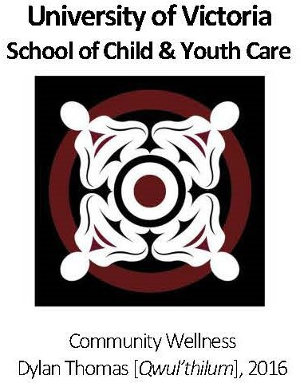
APPLICATION FORM
Master of Arts Program
Child, Youth, Family and Community Studies

*Please do not exceed the word maximum for each section.*
Please note: responses that go over word maximums will not be reviewed.

Please tell us how your background and social location shape your interest in this program: [200 word maximum]

Provide a summary of your relevant paid and/or volunteer work experience: [200 word maximum]

How has your experience with children, youth, families and/or communities prepared you for this program? [250 word maximum]

The CYFCS MA program requires research methods courses and the completion of a research project or thesis. It is, therefore, important that you provide a description of: [250 word maximum]
- your involvement in research projects, including undergraduate theses, research internships, or research assistantships. Highlight any practical experience and skills gained through participation in research projects.
- research courses you have taken, including research knowledge and skills you have acquired.

This program requires you to have a selected text-based research topic and question(s) that do not involve human participants for the start of the program in September. Please provide your specific research question(s) that you plan to explore: [250 word maximum]

Identify one or two specific topics of interest for your Master’s research, including a brief rationale.
[100 word maximum]

Please refer to the list of research faculty on our webpage and identify one or two potential academic supervisors based on your research question(s).

Please describe your key academic and/or professional strengths as related to Child, Youth, Family and Community Studies. [200 word maximum]

Please identify key challenges you anticipate facing in a graduate program and the tools and resources you would engage to meet these challenges. [200 word maximum]

What are your career goals on completion of this program? [100 word maximum]

Do you have any learning accessibility requirements that you would like to share? [50 word maximum]

We invite Indigenous applicants to share a personal statement, outlining your connection with one or more Indigenous communities and how your Indigenous identity informs your interest in our program. [250 word maximum]

I understand that this MA program includes a mandatory two-week summer institute held on the University of Victoria campus during the summer term.

I understand that this MA program is offered primarily online, aside from the mandatory two-week summer institute, and that course sessions may be both synchronous (live weekly sessions) and asynchronous. I also understand that, to participate in online courses, I am required to have a stable internet connection, a private space for joining videoconference sessions and videoconferencing equipment (camera, microphone, etc.).

I confirm that I have completed my application without any professional assistance or the use of generative AI.

Signature:

Date:

